Mapping as Rhetoric: Creating a Community Cycle Map in Defiance of Car Culture in Broward County.

Joanna Iovino-Sutherland
Nova Southeastern University
WRIT 5400 Technical Writing
Dr Eric Mason
November 21, 2023

Mapping as Rhetoric: Creating a Community Cycle Map in Defiance of Car Culture in Broward County.
Introduction
Maps and bicycles are both rhetorical by nature. The earliest known maps date back to 2300 BC, on Babylonian clay tablets (Lovell Johns). Maps assert as fact that which has been decided by their respective commissioners as truth. The first bicycle was created in 1817 (The Exploritorium), and since that time it has become an essential rhetoric for social justice, affording the freedom of inexpensive, reliable transport to people of all ages and classes. However, over the past century, as car ownership has expanded, the car has taken precedence over all other forms of transport in route planning: Google Maps has driving as a default mode of transport, drivers can confirm the location of speed cameras, there can be multiple alternate routes offered for car drivers based on preferences such as fuel efficiency, toll locations, and traffic, but no information pertinent to cyclists, such as hills, drop curbs, or cycle path locations. Cities can have roads with no cycle paths, roads with no sidewalks, and roads without safe crossings, but always roads, and Fort Lauderdale, Florida, is no exception in allowing the continued implicit rhetoric that driving a car is the norm, thereby relegating all other forms of transport to other. Therefore, in this project I am everting an official cycling map published by Broward Metropolitan Planning Organization (MPO) that categorizes cycle paths as ranging from easy to very difficult with limited information on relevant infrastructure (Broward Metropolitan Planning Organization [Broward MPO]). Creating my own map, to reveal the true challenges of cycling in Fort Lauderdale, Broward County – one of the deadliest counties for cyclists in the United States of America.
Broward MPO cycle map: Irrelevant, Unclear, Illogical.
In the past few years, Broward MPO created and published a cycle map using ArcGIS. (I have contacted this organization for more information about their choices in creating the map, and to ask which community organizations or individuals gave input, but they have not responded to date.) Broward MPO, a federally mandated public agency that claims to enable “seamless transportation and redevelopment in Broward County that provides an opportunity for people and communities to grow and thrive.” The organization creates local transportation policies and allocates federal funding for projects. The map (below) has color-coded some roads, the legend has them marked as easy, moderate, difficult, or very difficult.
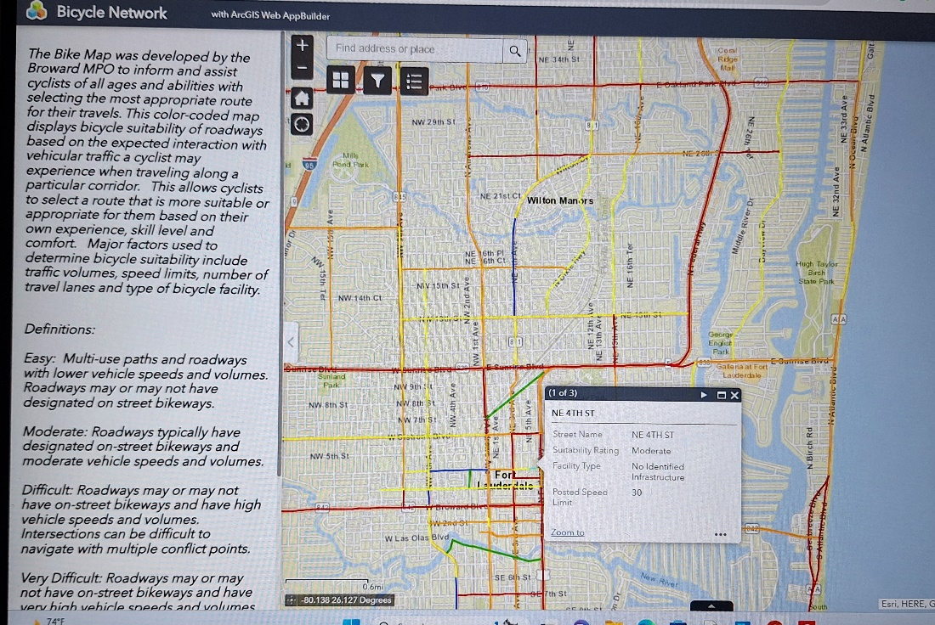
There is generalized information about each definition, but the language is so vague as to be unhelpful in planning a route, especially if considering additional safety factors such as cycling with young children or in large groups. For example, an easy route has “... multi-use paths and roadways … may or may not have designated on street (sic) bikeways”, while moderate reads “typically have designated on-street bikeways and moderate vehicle speeds”. Both descriptions leave room for routes to have - or not have - cycle paths. Routes classed as difficult and very difficult share an identical comment: “... may or may not have on-street bikeways … high vehicle speeds and volumes” with the only differential being that intersections are either “difficult to navigate with multiple conflict points” (Difficult) or are “most uncomfortable and difficult to navigate for people biking” (Very Difficult). As a cyclist, I can confirm that every road, and even some dedicated cycle paths, can have “multiple conflict points”. I created a word cloud of the legend’s language, which revealed a reliance on collective nouns, (roadways, bikeways, paths, people): abstract nouns (conflict, points, speeds); imprecise adverbs (typically); and subjective adjectives (difficult, easy, multiple, multi-use). This implies that the intent behind the map lacked precision, a clearly specified audience, and a consultation of the language to effectively communicate to that audience. In short, the map is inadequate to the point of dangerous as a tool to navigate Fort Lauderdale and surrounding area by bicycle.
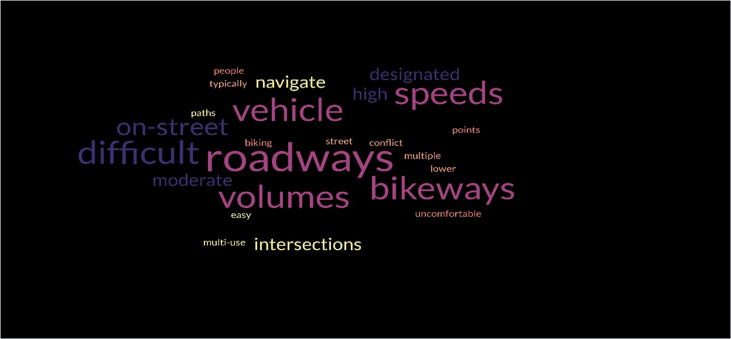
A clearer map for Broward cyclists
As a cyclist, I am frustrated at the lack of provision for this activity, which can be both leisure and transportation. My purposes for this map are dual; to give a clearer guide to fellow cyclists; to show the reasons for the high cyclist mortality rates, thereby becoming an advocacy tool for improvements to protest the skewed – and dangerous – assessment of the cycling network by an official body.
My risk and hazards map focuses on the same roads highlighted in the Broward MPO map, but with clear icons and notes to show different levels of risk and the factors that cause them. It aims to provide riders with a more accurate projection in terms of safety and enjoyment for their experience cycling popular routes in and around Fort Lauderdale (below).
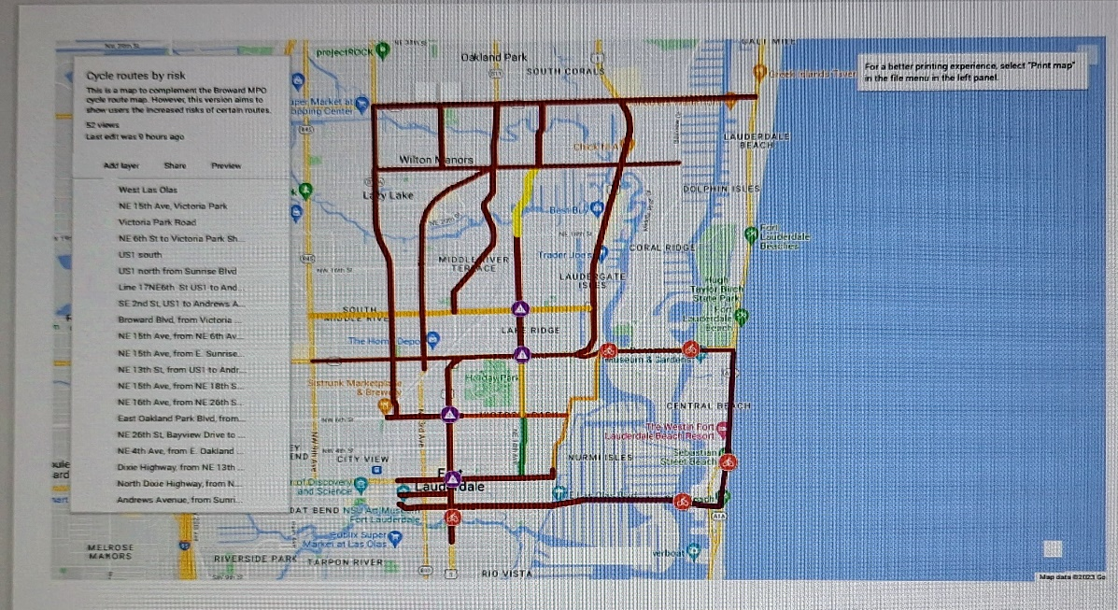 https://www.google.com/maps/d/edit?mid=1hCcjqmFM1Y72kC2PYvT6a2INS8YuRj4&ll=26.143326250256003%2C-80.1255544473639&z=14 (Click on link for fully accessible map)
This, in turn, may lead to a safer experience for cyclists as they will be able to make informed choices about whether to take the East Las Olas Boulevard (No physical buffers, bike lane narrow, busy road, adjacent to parked cars and shared with pedestrians) or the Riverwalk path above ground (shared pedestrian walkway, dismount if busy. Not ideal with very young children as there is no continuous between path and river.) The latter - despite being a traffic-free, pleasant, road alternative open to cyclists - is not shown on the MPO map. A world cloud for my legend shows a higher reliance on cyclist-facing language using precise nouns (buffer, lane, mph) and objective adjectives (suburban, multi-lane, off-road).
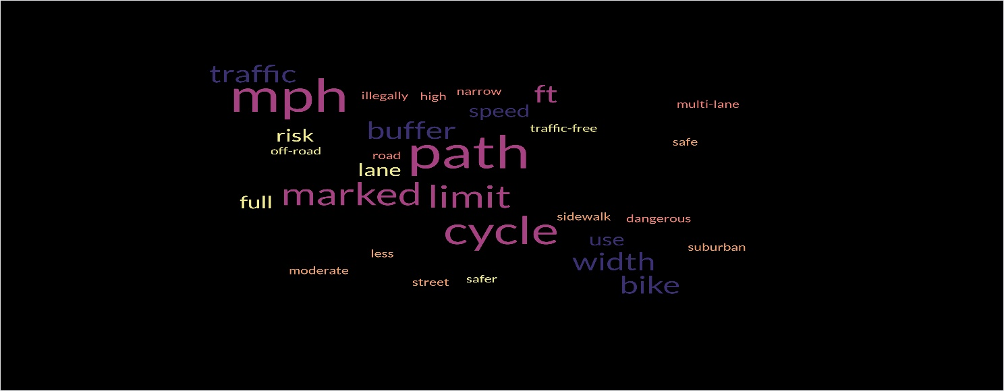
Fort Lauderdale and the surrounding area has the highest rate of cyclist injuries and deaths in the tri-county area, significantly contributing to Florida’s unenviable record in being named the most dangerous US state for bike riders. My customized Google map is creating a digital protest the MPO’s illogical rating, vague explanations, and incomplete labelling of roads and paths, I chose to collate my own information from almost a decade’s cycling in Fort Lauderdale and use this qualitative data as advocacy, to reveal the reasons behind the quantitative data. By using a publicly available, editable tool, I am also inviting others to add their qualitative data with the intention of being able to collate this data to advocate for more consultation and safer, linked-up infrastructure, not simply painting a sharrow on a three-lane road and calling it a route. Cyclist injuries and deaths are rising every year, having more than doubled in the past fifty years. My map is intended to expose the daily, fixable challenges which go on unchanged, year after year, as more cyclists suffer entirely preventable injuries and death despite their rights as road users.
Conclusion: Bicycles and maps as tools for freedom and equity.
Maps and bicycles are both suasive items in legal, political, health, monetary, and rhetorical fields. Maps control, or expand, our limits and boundaries; by mapping out a truer picture of the range of risks in cycling around Fort Lauderdale, I am helping to expand community knowledge and encourage to other cyclists to share their experiences into a participatory, community project. By mapping, I am creating space for bikes in my city. As a US citizen, amendment 1 of the Constitution grants me the right to life, liberty, and the pursuit of happiness. I choose to exercise all three of those through the medium of cycling. State legislation also claims rights, specifically that cyclists have the same rights, and responsibilities, as other vehicle drivers on the road. Additionally, cycling is a low-impact exercise which contributes to positive health outcomes, both physically and mentally. Finally, rhetorically speaking, cycling is an act of defiance. By cycling, I am declaring that I choose not to drive my car in this city built for cars, I choose not to burn gas that we wage wars to control. I choose effort, not ease, I choose exertion, not indolence. I choose flying past bumper-to-bumper single-passenger cars, as I assert my independence from car dependence.

References
Broward Metropolitan Planning Organization. (n.d.). [arcgis map]. www.browardmpo.org. Retrieved November 16, 2023, from https://browardmpo.maps.arcgis.com/apps/webappviewer/index.html?id=37e455c3e5554ca6b9ac34f5b59d31c1
Lovell Johns. (n.d.). Old Maps – A Brief History of Cartography [Blog]. Maps International. Retrieved November 16, 2023, from https://www.mapsinternational.co.uk/blog/old-maps-a-brief-history-of-cartography/#:~:text=Old%20Maps%20have%20been%20part,tablets%20from%20about%202300%20B.C.
The Exploritorium. (n.d.). Swiftwalkers. www.exploritorium.edu. Retrieved November 16, 2023, from https://www.exploratorium.edu/explore/cycling/frames#:~:text=German%20Inventor%20Karl%20von%20Drais,rims%20and%20leather%2Dcovered%20tires

Appendix
- How to create a customized map
This map was built using Google Maps, https://www.google.com/maps/about/mymaps
which is available for free, users just need a Google account to access this tool. There is an option to make the map public and searchable, to share it among preferred end-users.

The map, currently, can be used as intended to assist other cyclists in being aware of hazardous routes, as well a correction to the existing Broward Metropolitan Planning Organization’s current map which indicates only level of difficulty, without full details, and there is no additional information to explain how they came to the conclusions about these levels. For example, a lane on NE 4th Avenue which is too narrow to meet legal passing requirements, between two lanes of traffic, with no physical lane buffers, in a busy road outside a high school is categorized as easy, whereas two roads with little traffic in a quiet neighborhood and the right to use full lane are classified as difficult.

Instructions to create a customized Google map:
- Click on https://www.google.com/maps/about/mymaps/
- Sign in using an existing Google account, or sign up to create a Google account.
- In the top left-hand corner, click on the red button “Create New Map.”
- Use the menu to the left to create layers.
- Use the menu at the top left-hand side to create routes, add symbols, and notes to your map.
For more detailed instructions with example practice data: https://www.google.com/earth/outreach/learn/visualize-your-data-on-a-custom-map-using-google-my-maps/

Limitations of Google map:
- According to my research, it’s not possible to add a legend to Google Maps, so this needs to be created separately OR icons should be contextually understandable: red for more dangerous routes, etc. I’ve chosen to use contextually understandable colors and icons, and each icon and street is clickable for more detailed information, therefore no legend is needed for this map.
- When embedding the map into a website, the icons with annotations that I created are no longer clickable, therefore it’s necessary to add a link to the map with a brief explanation that the embedded image is for illustrative purposes, and users need to click on the link for the full map.
- It is possible to use code to create a map with a legend in Google Cloud Console; however, it’s not possible to import an existing custom Google Map into Google Cloud Console. It has to be originally created in GCC.
Contacting Broward MPO to discuss the purpose, scope, and limitations of their map.
From their website, I worked out who was likely the most relevant contacts, and emailed on 11/16/23 with the following questions:
Hello Carl and Ricardo,

I'm an NSU grad student researching bike transportation in Fort Lauderdale. I'm interested in the interactive cycle map on your website and wondered if you would be able to answer some questions or direct me to the best person to answer them.

- Which sub-groups of Broward MPO were responsible for delivering the map?
- What input was sought from any community groups and individuals, and how was this advertised?
- Which community groups/individuals gave input to the map?
- How was the rating system devised, and what was the rationale for each rating? (Easy, medium, difficult, very difficult).
- How long did the map take from initial concept to delivery?
- What was the total cost of producing the map?
- What was the intended purpose of the map?
- Who was the intended audience?

Many thanks,

Joanna

I received the following response on 11/21/23.

Hi, Joanna,

Ricardo is definitely going to be the best person to address your questions below. He is currently out, but should be back next week.

Carl Ema
Intergovernmental & Outreach Department
Administrative Services
Administrative Services Manager/Title VI Coordinator



